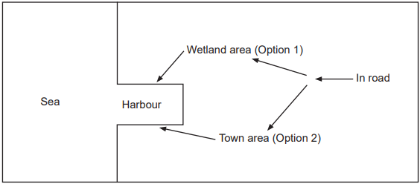
A port authority wants to reduce road congestion into its harbour to increase the productivity of the facility. It wants cargo trucks to get to the harbour from the existing ‘in road’ more quickly. Below is a ‘mud map’ of the port.
The authority is considering two options.
Option 1: Build a new road. The planned route of 5 km runs through a large wetland area. This would be a dual carriageway with several openings to allow movement of
water and native animals. The area also contains some plants and animals that are
considered endangered. The estimated cost is $250 million.
Option 2: Upgrade local roads through the adjoining town area to dual carriageways. The
estimated cost is $523 million, plus costs associated with compensating local
businesses that are affected during the upgrade.

Outline two arguments against Option 1, one economic and the other environmental.

Outline two arguments against Option 2, one economic and the other environmental

Evaluate your arguments for both options and explain which option you would recommend
to the port authority.

